Basic GUI Structure
Login Window

The system’s main login window requires you that a valid ‘User ID’ must be provided; otherwise it does not let you move an inch farther; that is, you can’t enter ‘Password’ before giving a valid ‘User ID’; once it is provided, you are allowed to ‘focus’ on the ‘Password’ text box.
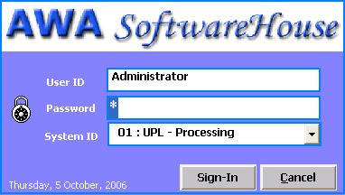
Note that:
- Invalid password is allowed with the system’s alert:
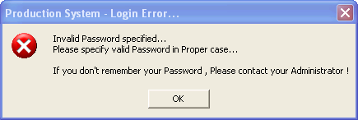
- Once a valid pair of User ID and Password is provided, you can select the system to work on (IF you have been assigned the rights!) from the combo box underneath
- The AWA Software House login windows is smart enough to remember you next time you login; it saves you from typing in ‘User ID’ again and again

Main Interface

The system main interface is designed to display five important categories of user interaction with the application; namely:

- Setup: Data entry forms for the system (business) entities
- Transactions: Data entry forms for the system transactions
- Reports: Parameter forms for viewing and/or taking print-outs of the system’s reports
- Utility Tools: Place for performing periodic processes such as Posting, Un-posting, Auditing, Backing-up or Restoring the database
- Security: Forms specifically designed for the administrator wherein he/she could configure system settings, create users access rights, view user activities, etc
These four types of system operations are provided in two ways: Main Menu and Tree View, as shown bellow:

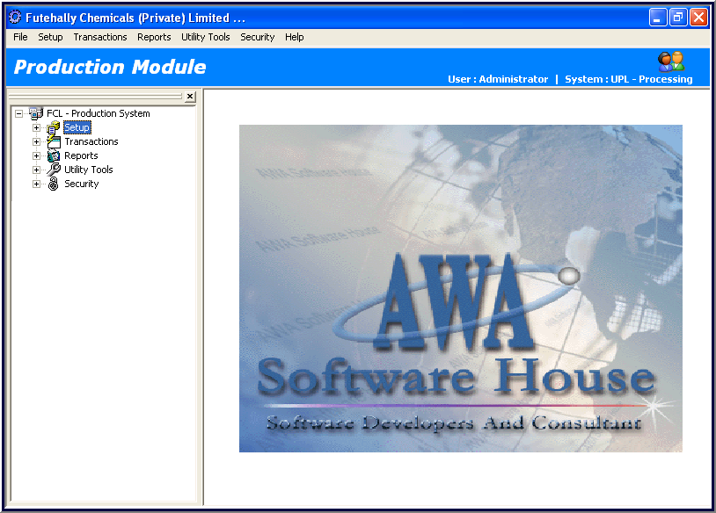
Current User

System/Sub-System

Note that:
- The blue bar at the top reads the system name on the left hand side; while you can see the currently logged in user along with the system/sub-system names on the right hand side
- A user can log off by clicking ‘Log Off…’ in the File menu OR by clicking on the close button:
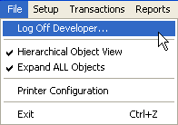 OR

- The ‘Hierarchical Object View’ item in the above File menu is a handy way to toggle between fixed or full view of the data entry forms; specially for a transaction data entry, uncheck this item and you will have a large and convenient form display

Setup
_______________________________________________________________________________

Each Setup entry is related to a business entity which may or may not have dependency on any other Setup entry. Click on a tree node (or the same menu item from Setup menu) and the data entry form opens up.

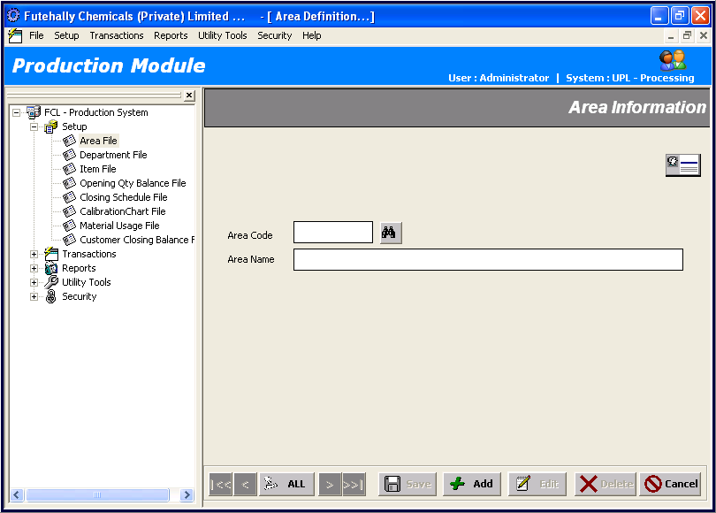

Close it to view the listing of all current records/entries in the respective setup entry database in the form of a grid-view which could be grouped by any column.

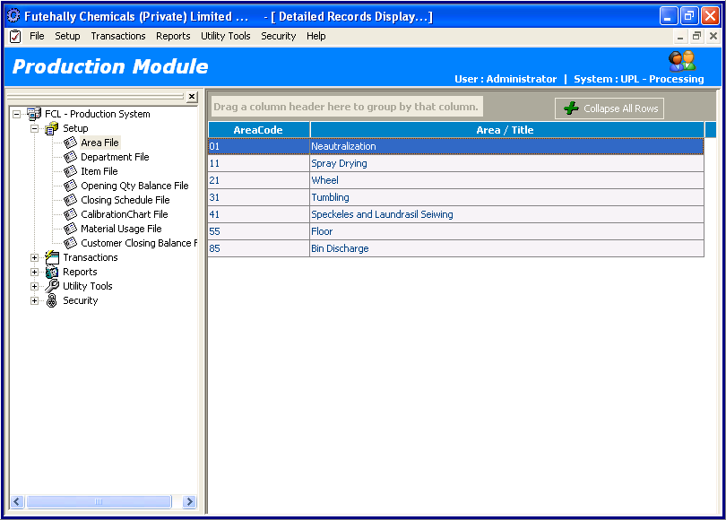

Table 1.1 gives you a quick help of using any Setup (and Transaction) data entry form.

Table 1.1 - General Guide for Setup and Transaction Forms
User Actions | System Response
1) Single-Click a Tree Node under Parent Nodes ‘Setup’ or ‘Transactions’  (or the same menu item from the Respective Main menu) | Form Opens up with all Fields Set for a New Data Entry Mode
2) Dbl-Click the Form-Behind Grid Displaying All Existing Records | Form Gets Populated with the Clicked Record
3) Click on Navigation Controls:   | System Fetches All Records into Memory and Shows up Very First Record.  System Sets Record Navigation Cursor at:  Very First Record  Previous Record  Next Record  Very Last Record
4) Click on Control Buttons: | System Performs the Respective Button Action as Follows:  Saves a New Record Entry with the Specified / Generated Code  Generates (or Validate the User’s Input) Valid Code and Sets the Remaining Fields Ready for a New Record Entry with That Code  Updates Changes Made to the Current Record  Deletes the Current Record  Resets the Form as Default (Add Mode) on First Click; Closes the Form on 2nd Click.
5) Click on Buttons with a Binoculars Image Or Pressing F2 with Cursor Focus on the Respective Code Field | Pops up the Quick Search Window with Records View and Search Functionalities Built-in ( Pressing ENTER or Dbl-Click Brings back the Selected Record into the Form Fields).
6) Press ENTER / TAB while in a Form Field | Moves the Cursor to the Next Field

Transactions
_______________________________________________________________________________

Click on a tree node (or the same menu item from Transaction menu) and the data entry form opens up. For best view, uncheck Hierarchal Object View from File menu.

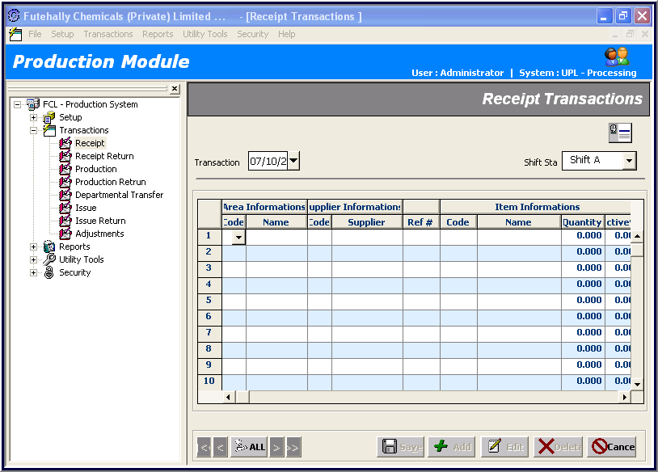
Note that:
- As mentioned earlier, uncheck the ‘Hierarchical Object View’ item in the above File and you will have a large and convenient transaction form display

Reports
_______________________________________________________________________________

Click on a tree node (or the same menu item from Reports menu) and the data entry form opens up.

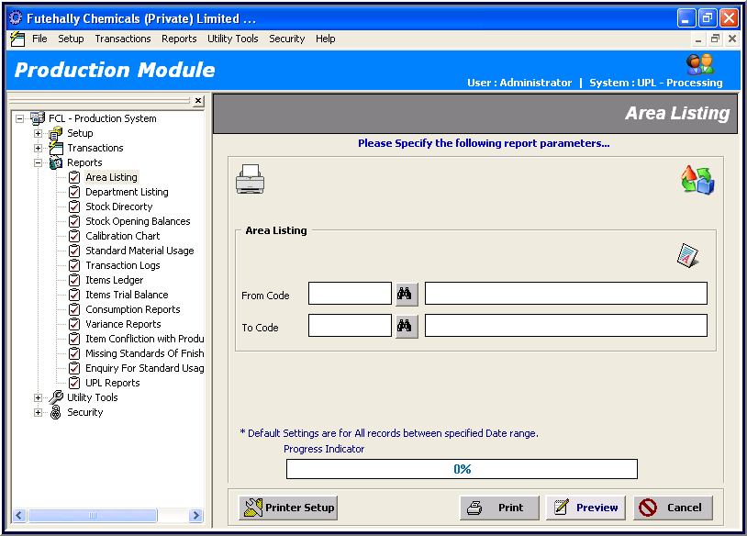

Note that if you don’t specify codes in textboxes, each report can be viewed with default parameters setting (empty code fields imply ‘all’) as the following label reads:

So, there is nothing mandatory in all report parameter forms. Combo boxes already hold one possible selection as default.

In all Reports forms, the following four buttons are provided:

After you have specified the report parameters from above, you can :
- set up your default printer by clicking

- print the report without taking a preview
by clicking
- take report preview with the help of Report Viewer by clicking
- click cancel to close the report form by clicking

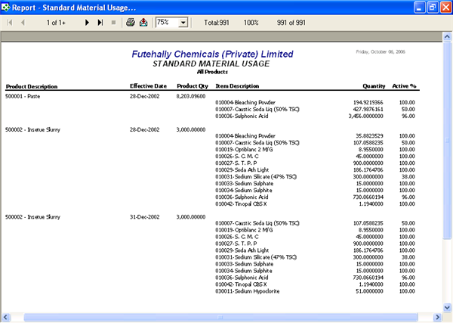
This is the snap shot of Report Viewer that opens up when you click on

button to get a preview of a report. At the top, you can find the following controls:
For report paging:
For opening Print Window to get the specified pages printed by your default printer, click on

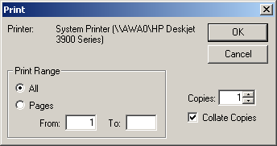
To export report in any other format, click on . This button pops up Export Window where your can specify which format to change report into and where to place the output file; that is, file destination.
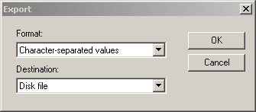

Clicking on OK button, Export Options Window appears that gives you an opportunity to specify
which pages you want to export.

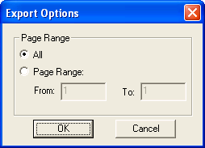

Utility Tools
_______________________________________________________________________________

Utility Tools cover periodic processes within a financial year period, such as:

- Auditing
- Posting Transactions
- Un-posting
As a security rule every Posting Process runs Auditing Process first so that as soon as some missing or invalid transactions are found in the currently ‘un-posted’ data, it denies posting even a single transaction. Note that the semantics and flow of these three processes vary with respect to the system.

Utility tools also cover processes that automate repeated tasks; such as applying validations, resetting rates, generating vouchers. Only authorized personnel have/should have the rights to operate these processes.

.
Message Boxes

AWA systems raise four kinds of message boxes:

- Invalid Data Entry Alerts: These messages help users identify what wrong they are doing:
e.g.
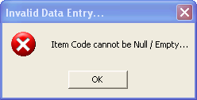
etc
- Genuine System Error Alerts: These messages show that something must be missing on the server-side! These are serious error messages. You should report to the system administrator:
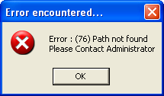
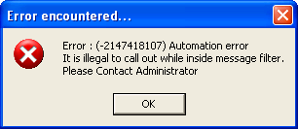
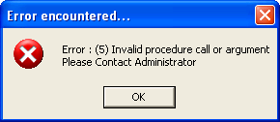
- Informative Alerts: No harm! Just click OK button to say good bye to these messages:
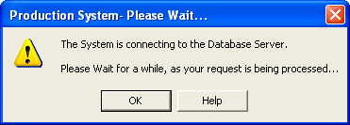
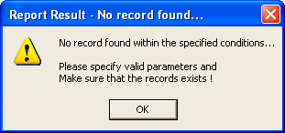
- Confirmation Alerts: Be sure! Once you click on the Yes button, there will be no way back:
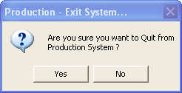
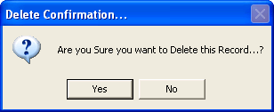

System Requirements
Software Requirements

AWA’s FCL ERP modules share almost the same software in order to run seamlessly on the client’s machines. Here’s the list of required software that must be installed on the server: (needs review) (must confirm it!)

- Microsoft SQL Server 2000
- Microsoft SQL Server Desktop Engine
Note that:
- A client on the network can run a module either by creating a shortcut to the module’s EXE file present on the server OR by installing the proxy on his/her machine

Recommended:

Win2k,xp
Service pack 2

Server:
Win adv svr
Sql

Hardware Requirements

AWA’s FCL ERP modules are light weight in terms of user interaction. But if (and obviously) the database lying on the server machine is large enough, it could well slow down the ‘response time’ a bit; for proficient use of these modules, the following hardware is advisable for the client and the server machines: (needs review) (must confirm it!)

Server Requirements
- Min 128 RAM
- 600 MHz Processor
Client Requirements
- Min 64 RAM
- 500 MHz Processor
Note that:
- FLC Payroll Module uses AWA’s MTX Attendance System for reading data from COM Port; hence, the server is required to be plugged up with the MTX Machines properly

Security Model
System Policy

This resort is dedicated for defining configurations exclusively applicable for a particular system sub-module. For example, in FCL Production Module the administrator defines the system policy about different items and areas of stock with the help of a particular coding convention. The system, then, uses this configuration to change its behavior for each sub-module of the production system.
Note that:
- As yet, System Policy is not utilized in other FCL Modules except for Production Module

Groups

With the help of Group Setup the administrator creates groups of users to be used while assigning rights to a new user.
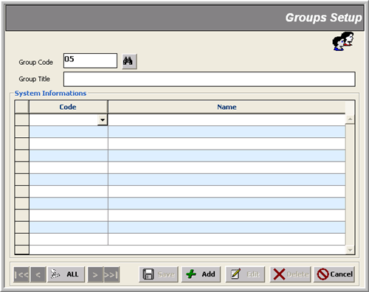

Users

In this form, a new user is created with all kinds of rights to interact with a Setup, Transaction or Reports data entry form.

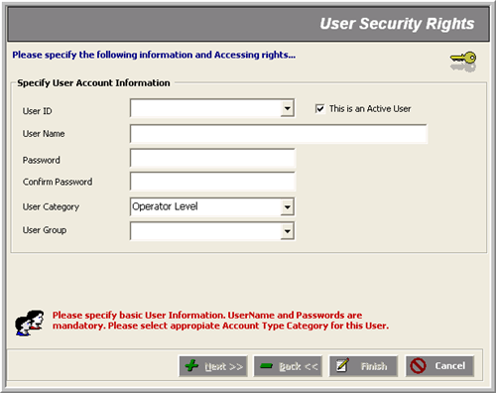

Note that:
- A user is assigned a particular ‘Category’ as well as ‘Group’ to further organize its accessibility options throughout the system
- Clicking on Next or Back buttons navigates the administrator to the system’s four kinds of forms where he/she can assign the indicated rights just by checking or un-checking options on the fly; changes made here come into action immediately after the Finished button is pressed
- The check-box labeled ‘This is an Active User’ enables or disables a user access altogether; that is, if it is not checked, the user will no longer be able to log in the system at all

